TRAVEL SERVICES

* Given below is a model diagram to show how travel services can be added to the implemented Travel Agency model.  
    
  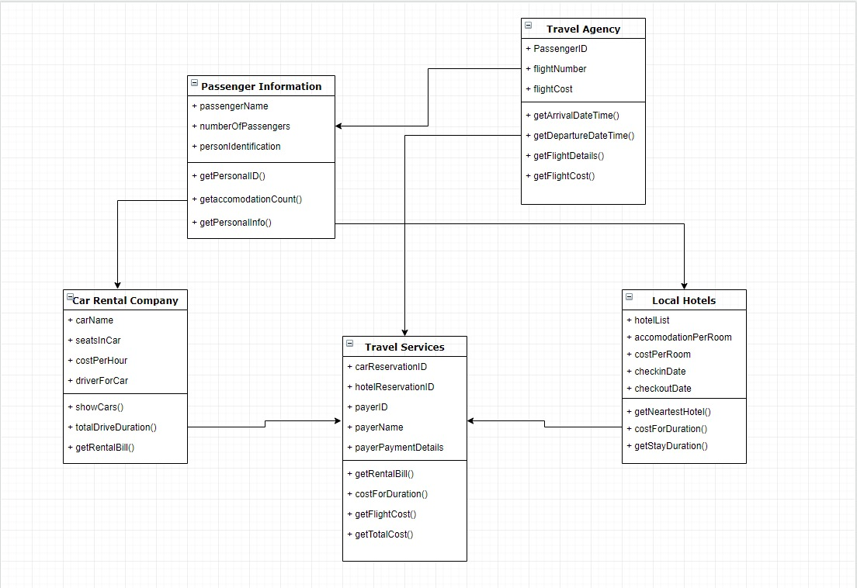

MODEL DIAGRAM ENTITIES:

* **Travel Services**  
  carReservationID, hotelReservationID, payerID, payerName, payerPaymentDetails
* **Car Rental Company**carName, seatsInCar, costPerHour, driverForCar
* Local Hotels  
  hotelList, accomodationPerRoom, costPerRoom, checkinDate, checkoutDate
* Passenger Information  
  passengerName, numberofPassengers, personIdentification
* Travel Agency  
  passengerID, flightNumber, flightCost

MODEL DIAGRAM BEHAVIOR (METHODS):

1. **Travel Services**Travel services takes the information generated regarding the passenger and other services offered to the passenger and it will provide a dashboard to show the overall summary. Once extended, the implemented travel agency will be a part of the travel services to show the aggregation
2. **Car Rental Company**Car rental companies, like the most we have seen, will first provide us with a list from its database for us to pick a car. For the billables regarding this entity, there will be a fixed price for the car to be rented, on an hourly basis. Hence, upon rental expiry and calculation of total hours, a bill can be calculated and passed
3. **Local Hotels**For the passengers that navigate to hotel reservations, it will use a method to look for the hotels close to the location chosen by passenger. Post that, it will be the usual hotel attributes as mentioned above. Like the car rental company, it will send it’s billing ahead to travel services.
4. **Passenger Information & Travel Agency:**As the implemented travel agency has the information regarding the passengers, it will be fetched as the input for the other services that we will be offering.